Story 03 - Book Filter - v3

Changes with respect to v2: see Technical Requirements

## Description

As a user

I want to filter the book overview

On price, title and color

## Wireframe

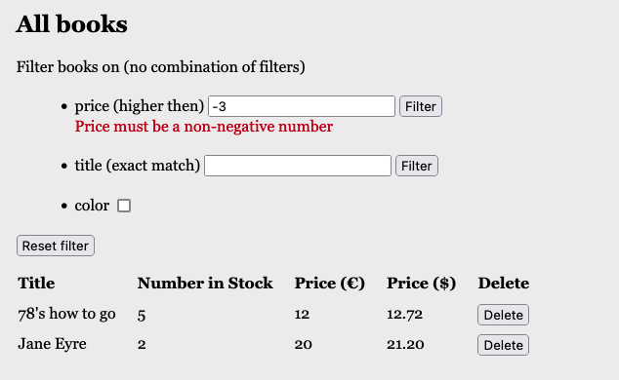

## Acceptance Criteria

* The screen shows three filter options
  1. Filter books on price: only books with price higher than given value are shown
  2. Filter books on title: only the book with the given title (exact match, not case sensitive) is shown
  3. Show only books that are in color (when check box is checked).
* Filtering only starts after clicking on the filter-button or checkbox.
* Filter values are shown in table overview
* If the filter value for price is a negative number, an error message is shown below the input field. The overview shows all books in the library.
* If the filter value for title counts less than 3 characters, an error message is shown.
* If the filter value for price or title is empty, the same error message as above is shown.
* Filters cannot be combined

## Technical Requirements

* The books are fetched from back-end by
  1. <http://localhost:8080/api/book/search/priceMoreThen?price=30>
  2. <http://localhost:8080/api/book/search/title/Jane%20Eyre>
  3. <http://localhost:8080/api/book/search/inColor>
* The response is a JSON array of books with fields “id” (int), “title” (String), “numberInStock” (int), “price” (double), “inColor” (Boolean), “priceInDollar” (double).
* If the filter value for price is negative or empty, the response of the search request is “400 BAD REQUEST” with a JSON error message with field “price-filter”

"price-filter": "The search value must be a non-negative number"

Tip: <https://www.baeldung.com/spring-request-param#a-default-value-for-the-request-parameter>

* If the filter value for title is empty or has less than 3 characters, the response of the search request is “400 BAD REQUEST” with a JSON error message with field “title-filter”

"title-filter": "Title must have at least 3 chars"

Tip: <https://www.baeldung.com/spring-pathvariable#making-an-optional-path-variable>

* The books are stored in a h2 database.
* Search queries are performed in a jpa repository (no implementation of search in BookService).